The Tempest （暴风雨）简介
————青苹果话剧系列丛书之一

Black Cat出版的The Tempest（暴风雨）是一本改编自莎士比亚作品的戏剧读物。该读物适用于小班授课，教师通过寓教于乐，可以更好地激发学生对英语的兴趣，家长也可通过话剧表演直观地看到到孩子的进步。

故事简介：
米兰公爵普洛斯彼罗由于闭门读书不理国事而被兄弟篡权，和女儿一起被放逐海上。因得到好心人的帮助，他们侥幸存活，流落到一座荒岛。普洛斯彼罗依靠书中学得的强大魔法，引仇人前来，令他们悔悟、认错。最后，普洛斯彼罗以博大的胸怀宽恕了仇敌，还为女儿找到了意中人，大家离开海岛回归米兰。

特点：
- 本书分8个单元以对话形式讲述故事，其中还穿插了2篇和相关的扩展阅读（Famous Shipwrecks和Magic and Magicians）以拓宽学生的知识面。学生可在各单元结束后进行话剧表演，也可在学完整个故事后表演。
- 各单元课文后有相应的理解练习、词汇练习、语法练习、口语练习和听力练习，部分练习是针对KET（注①）和Trinity（注②）考试而设。
- 含同步网络活动（Project on The Web），让学生在课外上网搜索更多的相关资料，以此调动学生的积极性。
- 本书最后附有Exit Test（有答案），可以检测学生对整本书的掌握能力。
- 图画吸引，便于学生模仿表演。
- 词汇较简单，适合CEFR（注③）A1水平、Trinity2级水平的学生，降低了对故事理解记忆和模仿表演时的难度。
- 随书附一张CD，内容为课文对话和听力测试。
- 教师可在Black Cat的网站（http://www.blackcat-cideb.com/）的TEACHER栏中下载答案和期末测验。

①KET—Key English Test
KET is Cambridge ESOL's exam which recognises the ability to deal with everyday written and spoken English at a basic level.
There are two versions of KET available: KET and KET for Schools. Both follow exactly the same format and the level of the question papers is identical. The only difference is that the content and treatment of topics in KET for Schools have been particularly targeted at the interests and experience of school pupils.

②Trinity College London ESOL is an international examinations board delivering assessments in English language learning and teaching and offering English language exams since 1938. It is the language division of Trinity College London. Language certificates offered include English for Speakers of Other Languages (ESOL) for non-native speakers of English, and Teaching English for Speakers of Other Languages (TESOL) for teachers of non-native speakers of English.

③CEFR—Common European Framework of Reference for Languages
CEFR is a guideline used to describe achievements of learners of foreign languages across Europe. Its main aim is to provide a method of assessing and teaching which applies to all languages in Europe.

目录
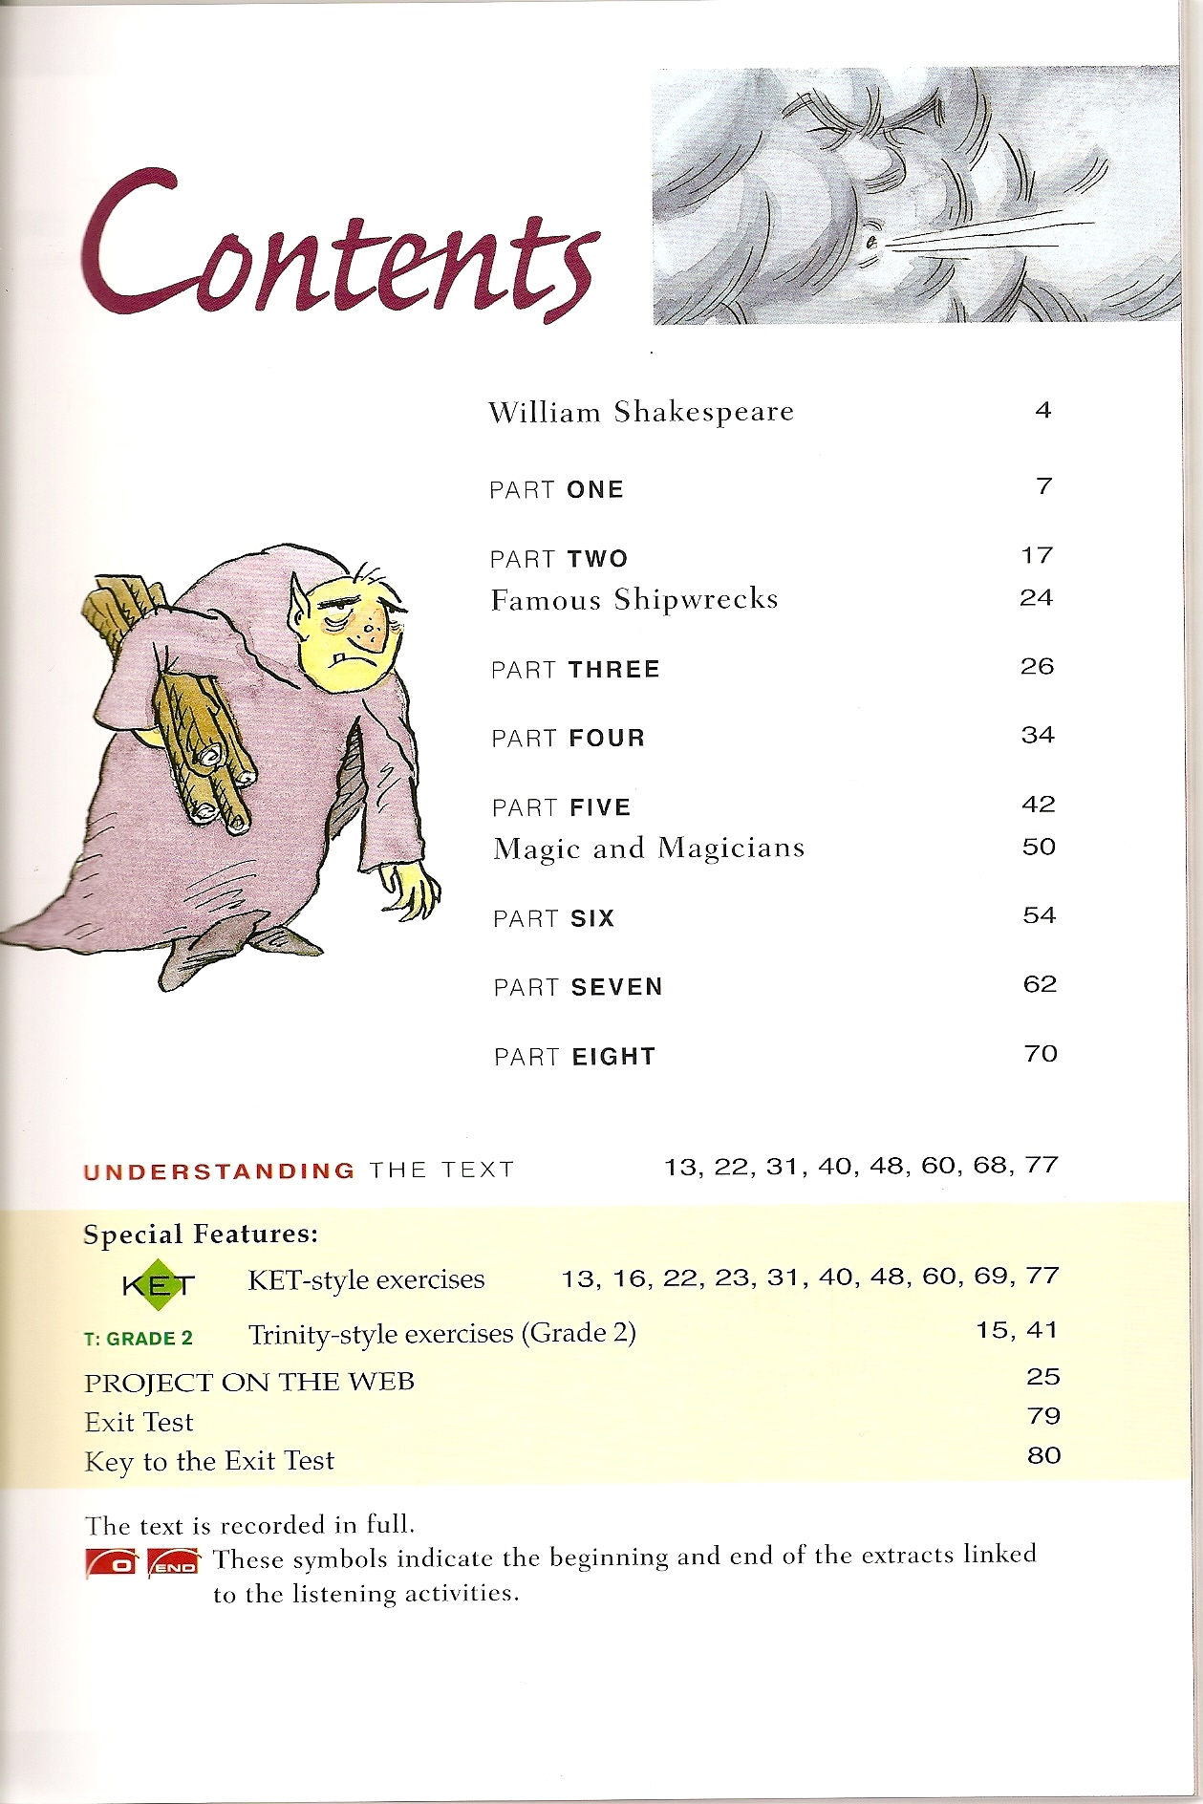

本书包含：人物介绍、课前热身、单元简介、课文对话、练习、扩展阅读以及Exit Test（附答案）。
使用介绍
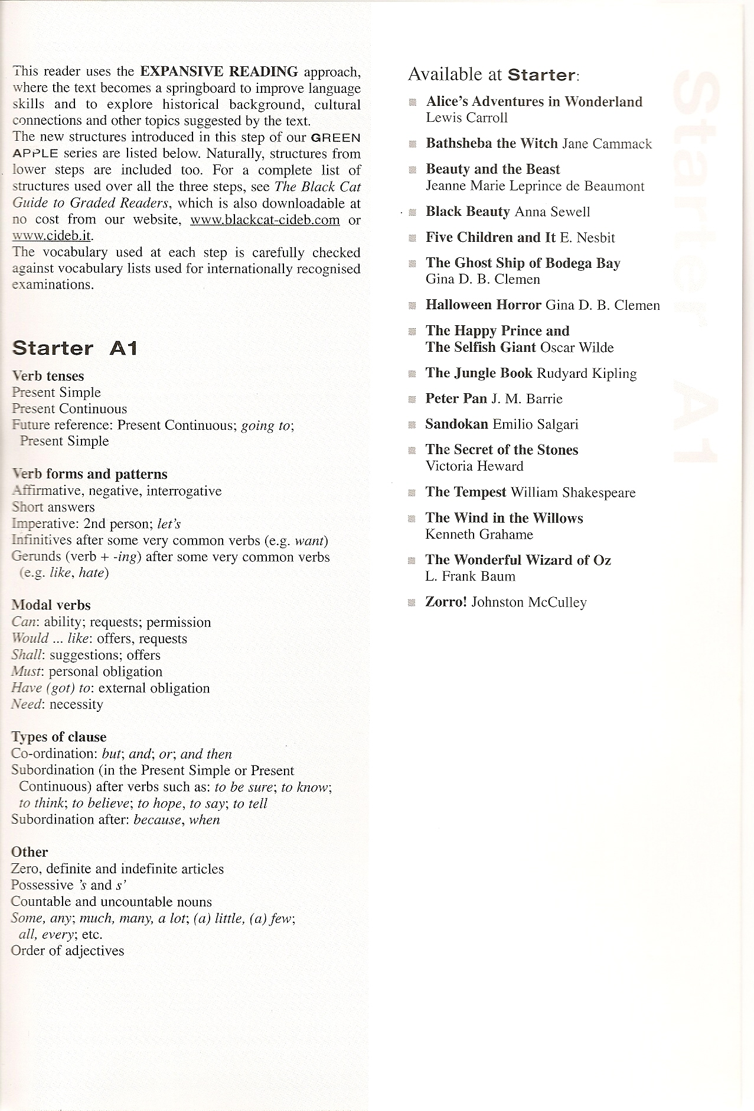
更多信息，请登陆出版社网站：http://www.blackcat-cideb.com/

