Newbery Medal
The Newbery Medal was named for eighteenth-century British bookseller John Newbery. It is awarded annually by the Association for Library Service to Children, a division of the American Library Association, to the author of the most distinguished contribution to American literature for children.

2009 Medal Winner
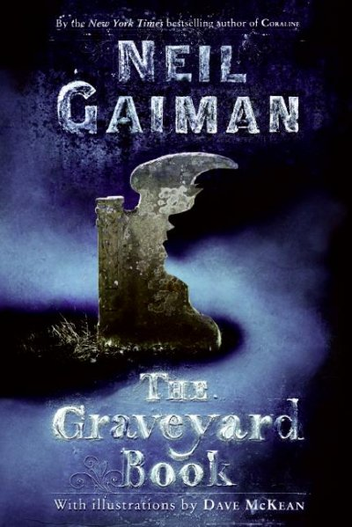
The 2009 Newbery Medal winner is The Graveyard Book by Neil Gaiman, illustrated by Dave McKean, and published by HarperCollins Children's Books.
A delicious mix of murder, fantasy, humor and human longing, the tale of Nobody Owens is told in magical, haunting prose. A child marked for death by an ancient league of assassins escapes into an abandoned graveyard, where he is reared and protected by its spirit denizens.
"A child named Nobody, an assassin, a graveyard and the dead are the perfect combination in this deliciously creepy tale, which is sometimes humorous, sometimes haunting and sometimes surprising," said Newbery Committee Chair Rose V. Treviño.

2009 Honor Books
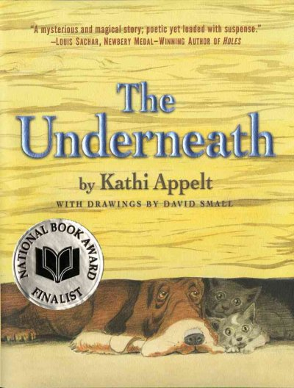
The Underneath by Kathi Appelt, illustrated by David Small (Atheneum Books for Young Readers, an imprint of Simon & Schuster Children's Publishing)
Underneath the canopy of the loblolly pines, amid the pulsating sounds of the swamp, there lies a tale. Intertwining stories of an embittered man, a loyal hound, an abandoned cat and a vengeful lamia sing of love, loss, loneliness and hope. Appelt's lyrical storytelling heightens the distinguished characteristics of this work.
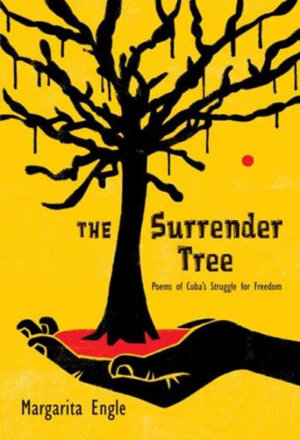
The Surrender Tree: Poems of Cuba's Struggle for Freedom by Margarita Engle (Henry Holt & Comapny)
The Surrender Tree utilizes compelling free verse in alternating voices to lyrically tell the story of Cuba's three wars for independence from Spain. Combining real-life characters (such as legendary healer Rosa La Bayamesa) with imagined individuals, Engle focuses on Rosa's struggle to save everyone--black, white, Cuban, Spanish, friend or enemy.
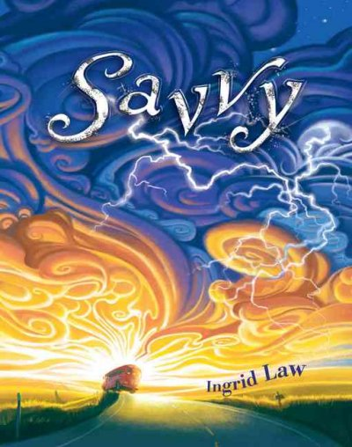
Savvy by Ingrid Law (Dial Books for Young Readers, a division of Penguin Young Readers Group in partnership with Walden Media, LLC)
This rich first-person narrative draws readers into a wild bus ride, winding through the countryside on a journey of self-discovery for Mibs Beaumont and her companions. Newcomer Law weaves a magical tall tale, using vivid language and lively personalities, all bouncing their way to a warm, satisfying conclusion.

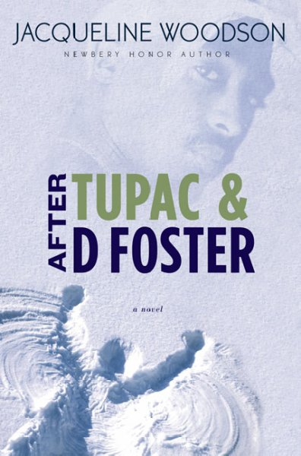
After Tupac & D Foster by Jacqueline Woodson (G.P. Putnam's Sons, a division of Penguin Books for Young Readers)
This tightly woven novel looks back on two years in a New York City neighborhood, where life changes for two 11-year-olds when a new girl joins their game of double Dutch. Bonded by Tupac's music, the three girls explore the lure of freedom and build a friendship that redefines their own identities.

Schneider Family Book Awards
The Schneider Family Book Awards honor an author or illustrator for a book that embodies an artistic expression of the disability experience for child and adolescent audiences. Three annual awards each consisting of $5000 and a framed plaque, will be given annually in each of the following categories: birth through grade school (age 0–8), middle school (age 9–13) and teens (age 14–18). (Age groupings are approximations).

The book must emphasize the artistic expression of the disability experience for children and or adolescent audiences. The book must portray some aspect of living with a disability or that of a friend or family member, whether the disability is physical, mental or emotional.

2009 Award Winners
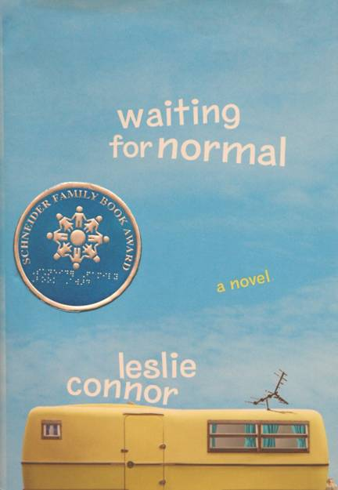
Leslie Connor is the winner of the middle-school award for Waiting for Normal, published by HarperCollins Children’s Books, a division of HarperCollins Publishers.
Addie has spent most of her twelve years “waiting for normal,” a stable family and a real home. Connor’s resilient heroine uses humor, creativity and her “love of learning” to compensate for her dyslexia. Through music and good friends, Addie discovers that she can accomplish anything.

Theodore Seuss Geisel Award
The Theodore Seuss Geisel Award is given annually to the author(s) and illustrator(s) of the most distinguished American book for beginning readers published in English in the United States during the preceding year.

2009 Medal winner
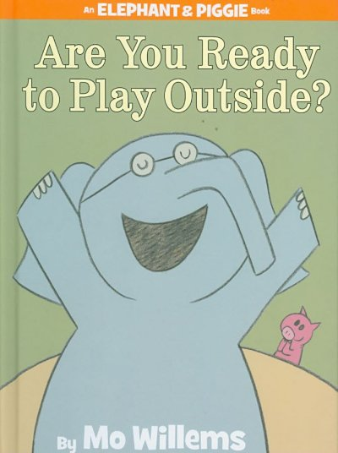
Are You Ready to Play Outside? by Mo Willems (Hyperion Books for Children, an imprint of Disney Book Group)
Willems has created a masterpiece for beginning readers that is simply told through the use of dialogue, which melds perfectly with uncluttered pink and grey cartoon-style illustrations. Aside from the friendship theme that appears throughout Willems’ work, he continues to create astonishing emotional depth using the simplest of facial expressions on his characters. Are You Ready to Play Outside? tracks Piggie’s changing feelings about rainy weather and Gerald’s heroic efforts to help her grapple with her disappointments in a satisfying story arc.
“Mo Willems’ easily approachable text, captured in dialogue balloons and bold, expressive drawing of friends Piggie and Gerald experiencing the ups and downs of a rainy day, deliver laughter and love of story to beginning readers,” said Geisel Award Committee Chair Joan Atkinson.

2009 Honor Books
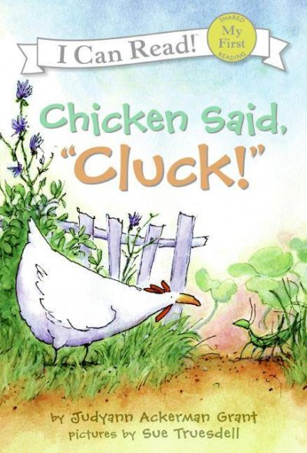
Chicken Said, ‘Cluck!’ by Judyann Ackerman Grant, illustrated by Sue Truesdell (HarperCollins Children’s Books, a division of HarperCollins Publishers)
Earl and Pearl shoo Chicken away as they work on their pumpkin patch, but as the story comes full circle, it’s Chicken who does the shooing and saves the day. In this traditional yet fresh easy reader, even very new readers can understand the simple, symmetrical text together with the funny and endearing pictures that capture every emotion of the two young gardeners and the sometimes annoying Chicken.
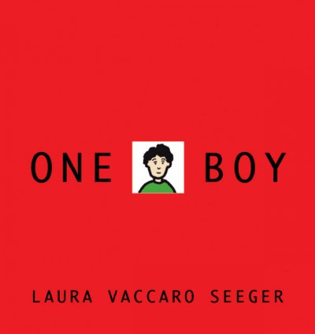
One Boy, written and illustrated by Laura Vaccaro Seeger (A Neal Porter Book published by Roaring Brook Press, a division of Holtzbrinck Publishing Holdings Limited Partnership)
One Boy is an eye-catching picture book leading readers to discover words within words through a distinctive die-cut design and clean, bold illustrations. A surprise conclusion satisfyingly completes this unique tale of one boy’s artistic visions.

Mildred L. Batchelder Award
The Mildred L. Batchelder Award is a citation awarded to an American publisher for a children's book considered to be the most outstanding of those books originally published in a foreign language in a foreign country, and subsequently translated into English and published in the United States.

2009 Award winner
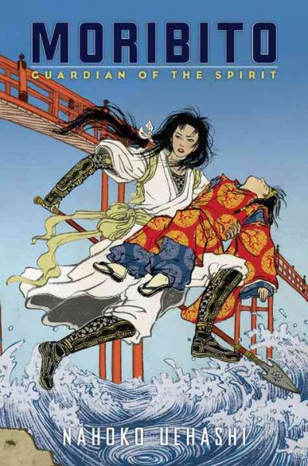
Arthur A. Levine Books, an imprint of Scholastic Inc. for Moribito: Guardian of the Spirit, writtten by Nahoko Uehashi, translated from the Japanese by Cathy Hirano.
The book tells the story of Balsa, a skilled female warrior, who accepts the task of protecting a young prince from otherworldly demons and his father’s assassins. Prince Chagum is the Moribito, the guardian of the sacred spirit. If Balsa is unsuccessful in protecting the prince, the country will suffer years of devastating drought so together they must find in each other the source of strength they need to prevail.
“This sophisticated and complex Japanese epic is filled with political intrigue, mystery and danger,” said Batchelder Committee Chair Sandra Imdieke.

2009 Honor Books
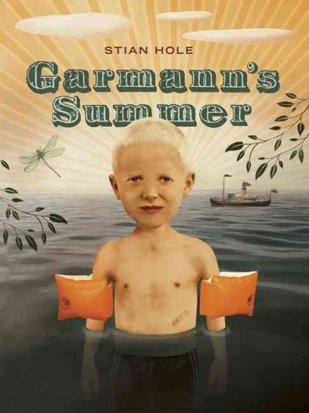
Eerdmans Books for Young Readers, an imprint of Wm. B. Eerdmans Publishing Co. for Garmann’s Summer, written and illustrated by Stian Hole, translated from the Norwegian by Don Bartlett.
Hole introduces us to six-year-old Garmann during his last summer before starting school. The humorous and poetic text, combined with surreal and multi-layered artwork, creates a truly unique and complex look at the universality of fear and uncertainty.
“This is a book rich with literary and visual complexity, but it will be Garmann who readers remember,” said Imdieke.
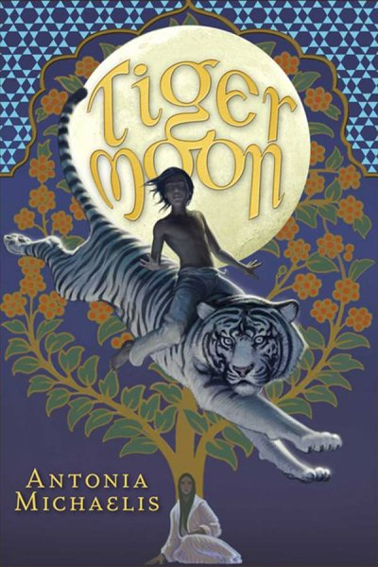
Amulet Books, an imprint of Harry N. Abrams, Inc. for Tiger Moon, written by Antonia Michaelis, translated from the German by Anthea Bell.
A betrayed woman facing death, a most unlikely hero, and a sarcastic talking white tiger in colonial-era India come together in a magical story within a story. Antonia Michaelis’ masterfully crafted tale moves seamlessly from reality to fantasy as it reveals the profound power of story.
“Stories are an excellent way to escape,’says Safia, who in this tale literally proves this to be true,” said Imdieke.

Michael L. Printz Award
The Michael L. Printz Award is an award for a book that exemplifies literary excellence in young adult literature. It is named for a Topeka, Kansas school librarian who was a long-time active member of the Young Adult Library Services Association. The award is sponsored by Booklist, a publication of the American Library Association.
2009 Award Winner
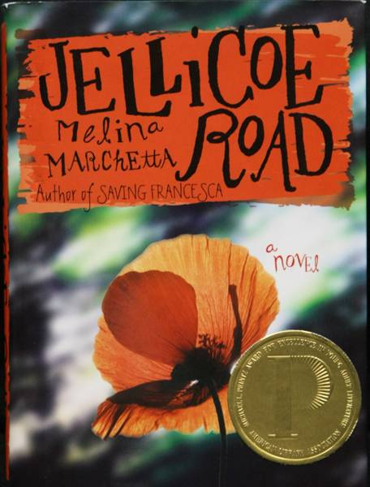
Jellicoe Road
by Melina Marchetta
published by HarperTeen, an imprint of HarperCollins Publishers
Haunted by the past, Taylor Markham reluctantly leads the students of the Jellicoe School in their secret territory wars against the Townies and the Cadets. Marchetta’s lyrical writing evokes the Australian landscape in a suspenseful tale of raw emotion, romance, humor and tragedy.
Melina Marchetta lives in Sydney, Australia, and is the award-winning author of two previous novels. A former high school teacher, she is recognized for the authenticity of her teen characters’ voices.
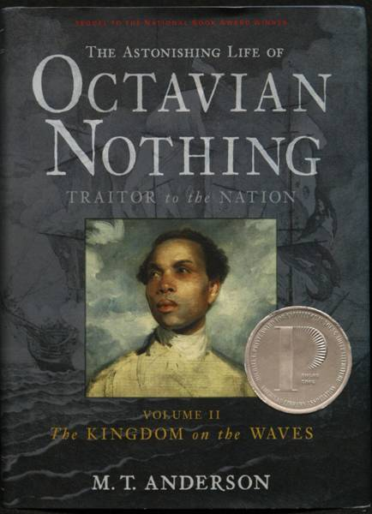
“This roller coaster ride of a novel grabs you from the first sentence and doesn’t let go. You may not be sure where the ride will take you, but every detail—from the complexities of the dual narrative to the pangs of first love—is pitch perfect,” said Printz Award Committee Chair Mary Arnold.
2009 Printz Honor Books
The Astonishing Life of Octavian Nothing, Traitor to the Nation, Volume II, The Kingdom on the Waves, by M.T. Anderson, published by Candlewick Press.
Caught in the crossfire of the American Revolution, escaped slave Octavian joins the British army in hopes of finally securing his own freedom.
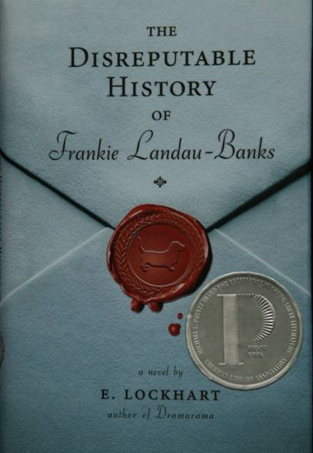
The Disreputable History of Frankie Landau-Banks, by E. Lockhart, published by Disney-Hyperion, an imprint of Disney Book Group.
Can the old-boy network at her elite boarding school survive the mal-doings of Frankie Landau-Banks?
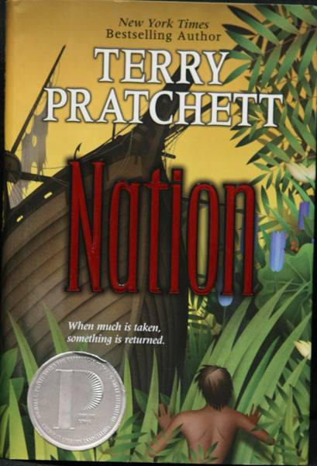
Nation, by Terry Pratchett, published by HarperCollins Children’s Books, a division of HarperCollins Publishers.
Pratchett’s trademark humor leavens this epic tale of ravaged islands, shipwrecked nobles and survival.

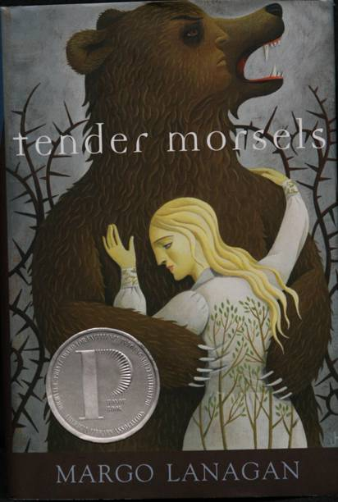
Tender Morsels, by Margo Lanagan, published by Alfred A. Knopf, an imprint of Random House Children’s Books, a division of Random House, Inc., New York.
In utterly original language, Lanagan re-imagines “Snow White and Rose Red” and explores the brutality and beauty of life.

